Boutonniere:

Size of buckets close in width and length (will be on floor and with sunflowers, see below pic):
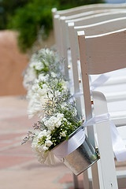

Sunflowers in Isle buckets. Close to width of our buckets but this picture height is taller):
