Flowers for
Montez Wedding
7/30/16

Venue: Ironstone Winery
The Basics
Color Palette Summary: Gold, Rose Gold, Bronze, Copper, White 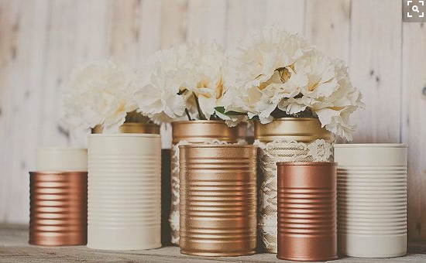
Pops of color: Very light pink, pink, light greens (for bride light pink and pink for bridesmaids bouquet)
NOTE THE CANS ABOVE PROVIDED BY BRIDE ALREADY PAINTED AND VARIOUS SIZES

Ceremony
(2) Wine Barrels @ the beginning of the aisle
(2) Wine Barrels @ the alter

(2) On top of Wine Barrels @ the beginning of the aisle - cascading flowers (photos below just for visual purpose -- not for the purpose of showing you what flowers bride wants.

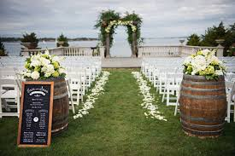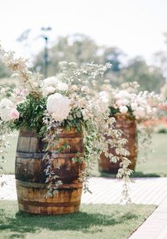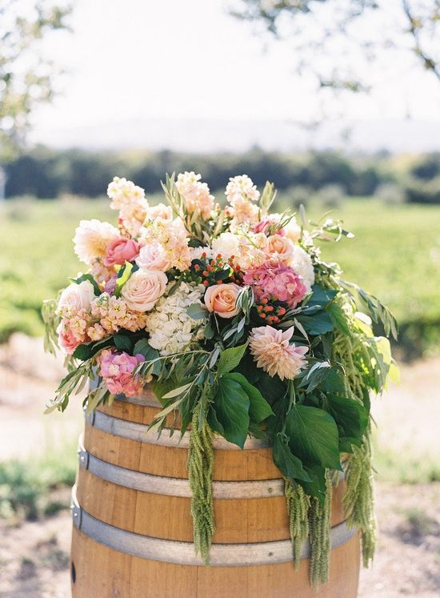

(14) hanging small jars along side of inner chairs on sheppard hooks - just use similar flowers as in bouquets
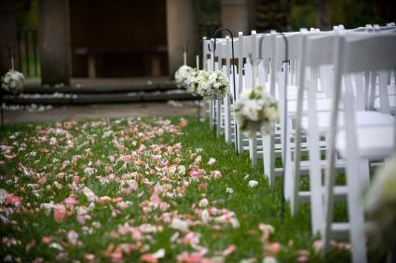

Wedding Party
Brides bouquet (1) Type of flowers to be determined by Bride
use Satin material covering the stems
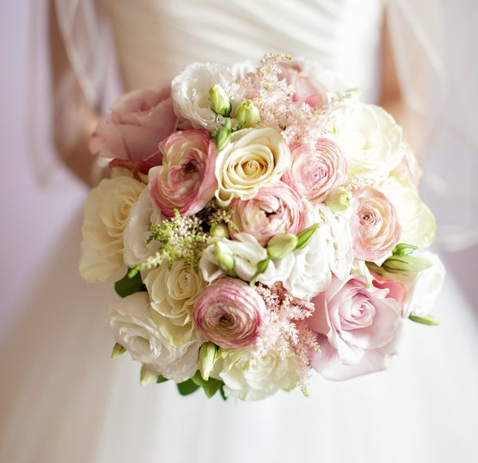

Brides “toss bouquet” (1)
Simple version of the bride’s bouquet

Bridesmaids: (8) Type of flowers to be determined by bride
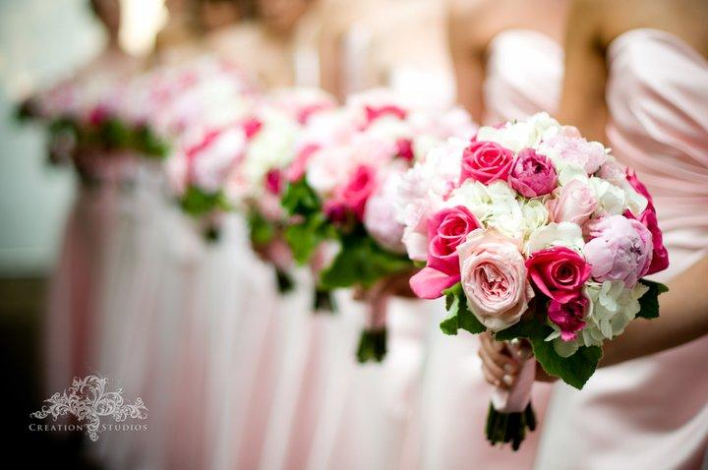

Flowergirl(s) 1
- also need rose petals for basket and on the isle where bridal walks down

Groom/Groomsmen: Johnnie (1) Groomsmen (8)
Similar to the bride’s flowers again not yet determine

Ringbearer (1)

Father(s) 2
Mother(s) 2

Grandmother(s) 3
Grandfather 1

Cocktail Hour
(6) Highboy tables
(6) Floral centerpieces; (1) small floral arrangement with white/ pink flowers in Stumptown Coffee Cold Brew bottle (see picture below)

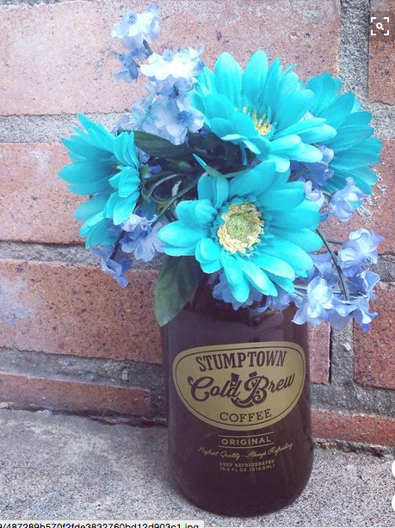NOTE pic is just for idea purposes - not specifically for the type of flower used

Reception/Dinner
(18) centerpieces
(1) centerpiece at Groom and Bridal Table or (1) empty vase for Bride to put throw bouquet in
(1) Bar location
(1) flower piece on coffee table at the soft seating area (see pic below)
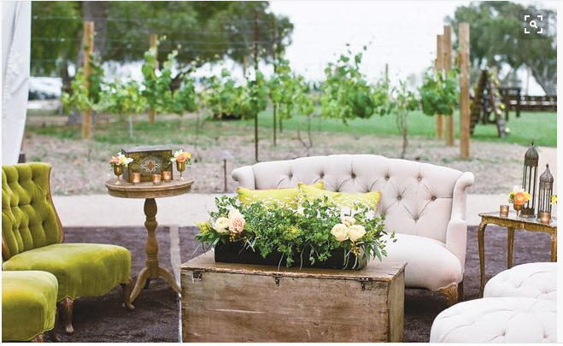

NOTE Need (8) empty vases for bridesmaid to put their flowers in (looks beautiful and also poses as flower decor on table)

NOTE Utilize the 4 barrel flower pieces inside reception on the rockery

NOTE: remove the hanging flowers at the ceremony and layout on the stone walls in the reception area. Also include smaller version of centerpiece (using single cans)

